Structure of Memory size of 8085
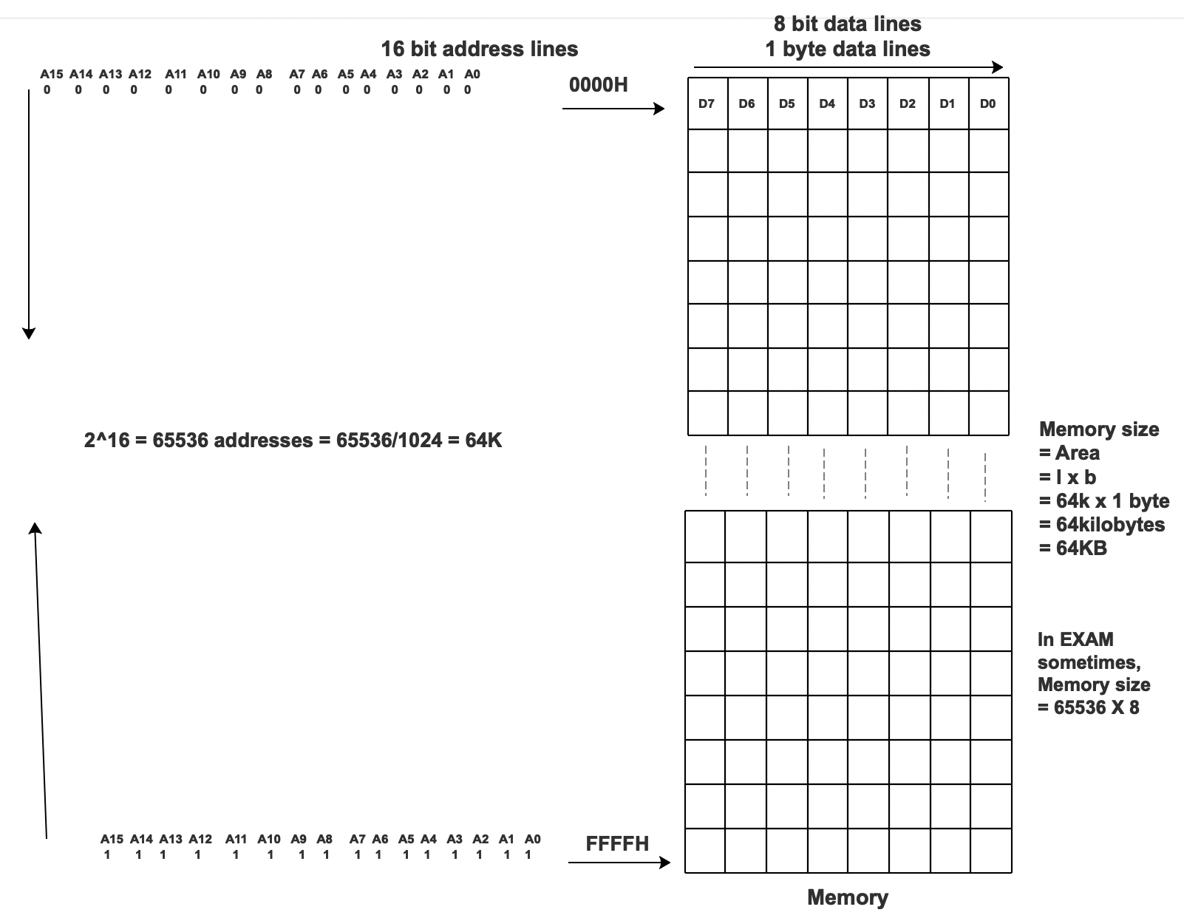

Detailed structure of 64KB memory with data, address and control lines

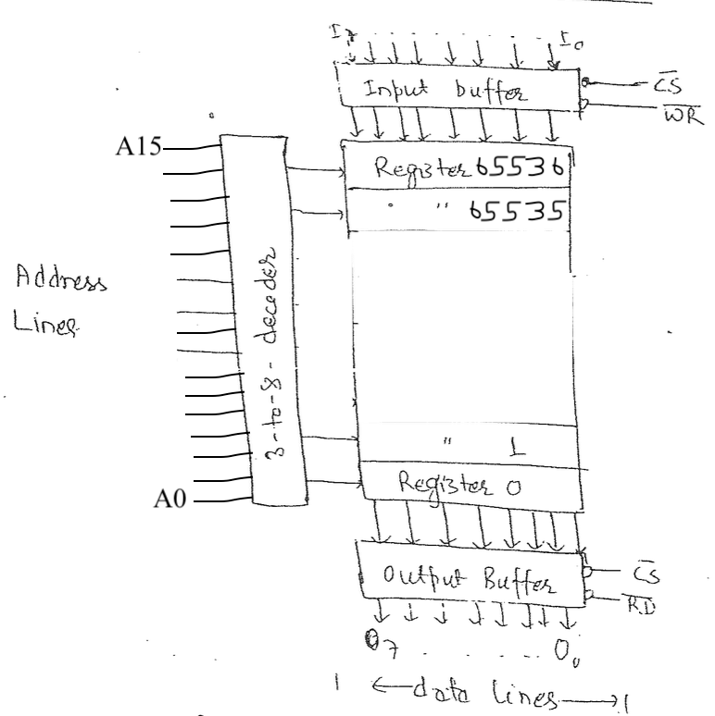

Block diagram for RAM and ROM
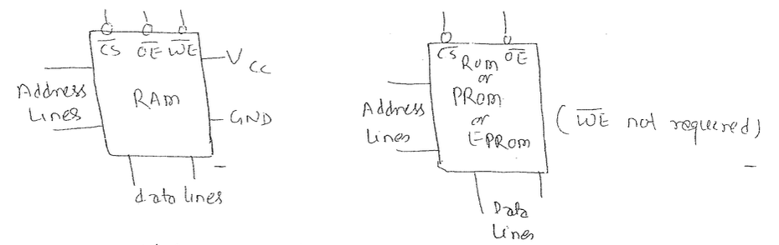
Interfacing a 8085 microprocessor with 64KB RAM
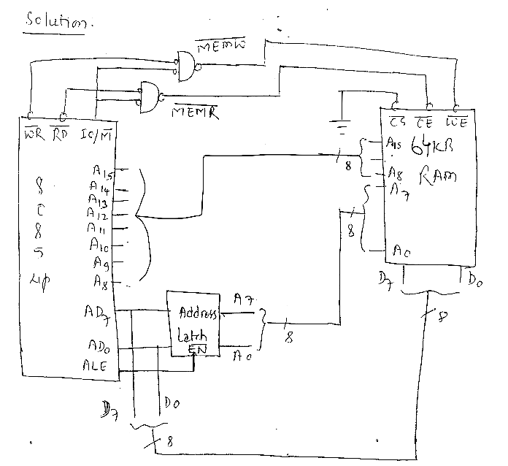
- Design a memory circuit to interface a 2 K-byte RAM to an 8085 microprocessor with starting address 7000H.
Step 1
Find the number of address lines and chip select lines
Represent them in two form 2^{N} x byte, where N represents the number of address lines
2K byte = (2 x 1024 ) x byte
= 2¹ x 2¹⁰ x byte
= 2¹¹ x byte
which means 11 addr lines (A₀ to A₁₀) required to go to the memory
But microprocessor has 16 addr lines, so remaining 5 addr lines(A₁₁ to A₁₅ ) selects the chip
Therefore, address lines = 11 (A₀ to A₁₀) and
Chip select lines = 5 (A₁₁ to A₁₅)

Step 2

Check if the starting address is given or not.
Case 1: Starting address given
If given use that as the starting address say 7000H

Then, write the range for as single RAM chip as follows
A₁₅ A₁₄ A₁₃ A₁₂ A₁₁ A₁₀ A₀
7000_{H} = 0 1 1 1 0 0 0 0 0 0 0 0 0 0 0 0
77FF_{H} = 0 1 1 1 0 1 1 1 1 1 1 1 1 1 1 1

Case 2: Starting address not given
If not given assume starting address as 0000H

Then, write the range for a single RAM chip as follows
A₁₅ A₁₄ A₁₃ A₁₂ A₁₁ A₁₀ A₀
0000_{H} = 0 0 0 0 0 0 0 0 0 0 0 0 0 0 0 0
07FF_{H} = 0 0 0 0 0 1 1 1 1 1 1 1 1 1 1 1

In both the cases we find one thing remains same that is chip select lines, while address lines change its values.

**Note: These chip select lines should be given to the logic gates in such a way that they output logic 0 to enable chip select lines on the given memory chip.

Step 3

Draw the interfacing figure with the above address lines, chip select lines and necessary control signals.
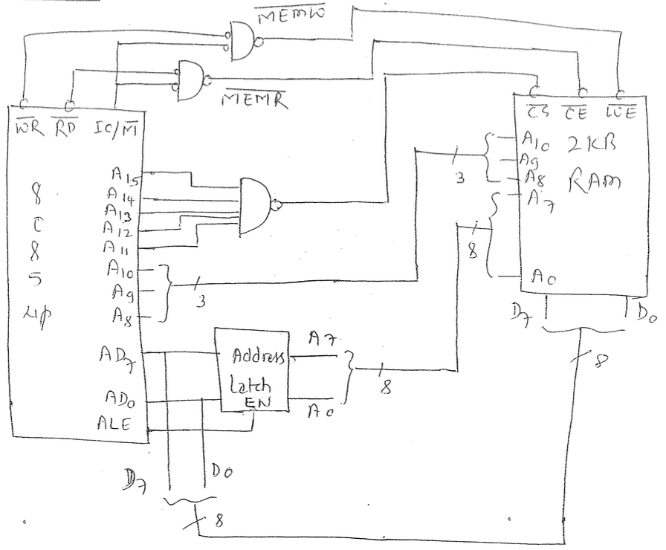
Fig: Circuit interfacing 2KB RAM with 8085 microprocessor
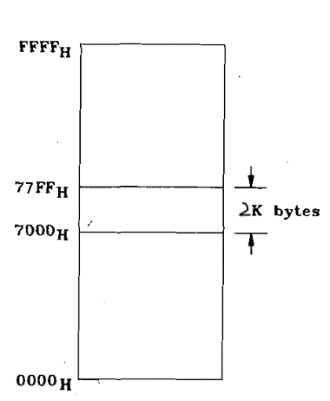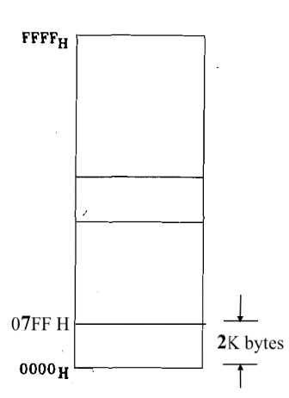
Fig: Memory Map (Case 1) Fig: Memory Map (Case 2)
- Design a memory circuit to interface a 32K-byte RAM and 32K-byte ROM to an 8085 microprocessor with starting address 1000H. Find the address range.
Note: Write the address range yourself. Homework.
